**SOCIAL MEDIA MESSAGES: Targeting Excavators this 8/11 Day (Aug. 11)**

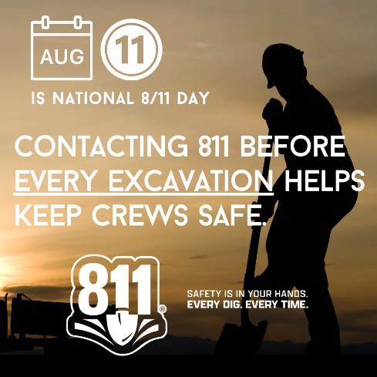

**MESSAGE 1:** National 8/11 Day – Aug. 11 – is just around the corner, and it’s a natural reminder to always #contact811 before every digging project, every time. This 8/11 Day, commit to using #811beforeyoudig for #everydig, #everytime to keep yourself and your community safe.

**MESSAGE 2:** Today is 8/11 Day, but did you know that one of the top reasons professionals cite for not contacting 811 before every digging project is that they think they already know where buried utilities are located? Even if your crew has worked a jobsite before, weather, erosion and construction can affect the perceived location of facilities – always contact #811beforeyoudig, #everydigeverytime.